**Automatic car parking system**

**Team members:**

Hari Babu Hasini -am.en.u4ece22122

N.Harshitha - am.en.u4ece22123

Kothala Gnana Shanmukha -am.en.u4ece22124

Kudari Ritika - am.en.u4ece22125

**OBJECTIVE:**

Automatic Car Parking System Project Using Arduino

**HARDWARE REQUIRED:**

1)[Arduino UNO](https://techatronic.com/what-is-arduino-brief-description/)

2)[Two IR sensors](https://techatronic.com/what-is-an-ir-sensor/)

3)[Servo motor](https://techatronic.com/tutorial-to-understand-the-working-of-servo-motors-using-arduino/)

4)Jumper wires and a breadboard

5)[16×2 LCD](https://techatronic.com/interface-lcd-with-arduino-16x2/) and an [I2C module](https://techatronic.com/lcd-interfacing-with-arduino-using-i2c/)

6)USB cable for uploading the code

**THEORY:**

The system automatically detects whether the parking slot is empty or not. If the slot is empty in theautomated car parking the new vehicles are allowed to enter else the entrance is blocked by the servo barrier in case the parking is full. This ever growing traffic congestion and uncertainty in the parking availability and payment have thus enforced the need for a Smart Parking systems. A Smart parking technology that will help optimize parking space usage, improve the efficiency of the parking operations and help smoother traffic flow. The system automatically detects whether the parking slot is empty or not. If the slot is empty in the automated car parking the new vehicles are allowed to enter else the entrance is blocked by the servo barrier in case the parking is full. The visitors can see the status for the availability of the free space outside the parking on a 16×2 LCD. They can also see on the LCD how many parking slots are free. The data keeps updating as the vehicles move in and out of the parking. Smart parking solutions enable the municipalities to manage and reduce parking search traffic on the streets Vehicles that are circling looking for an open parking space cause most of the city traffic. In addition, very driving around burns a lot of fuel and emissions daily. Our parking management system can significantly reduce city traffic, driving time and air pollution.

**PROCEDURE**:

1)connect the 5 volts pin of the Arduino with the VCC pin of the I2C module, the red wire of the servo motor, and the VCC pin of both the IR sensors.

2)Join the SDA pin of the I2C module with the analog-4 pin of the Arduino and the SCL pin of the I2C module with the analog-5 pin of the Arduino in thisautomatic car parking system project**.**

3)Connect the GND pin of the Arduino with the GND pin of the [I2C module,](https://techatronic.com/i2c-scanner/) the brown wire of the servo motor, and the GND pin of both the IR sensors. Attach the orange(signal) wire of the servo motor to the digital-9 pin of the Arduino.

4)connect the pins of the I2C module with the pins of 16×2 LCD.

5)check here the interfacing of [16×2 LCD with the I2C](https://techatronic.com/lcd-interfacing-with-arduino-using-i2c/) module. At last, connect the OUT pin of the first IR sensor with the digital-4 pin of the Arduino and the OUT pin of the second [IR sensor](https://techatronic.com/what-is-an-ir-sensor/) with the digital-7 pin of the Arduino.

**CIRCUIT DIAGRAM:**

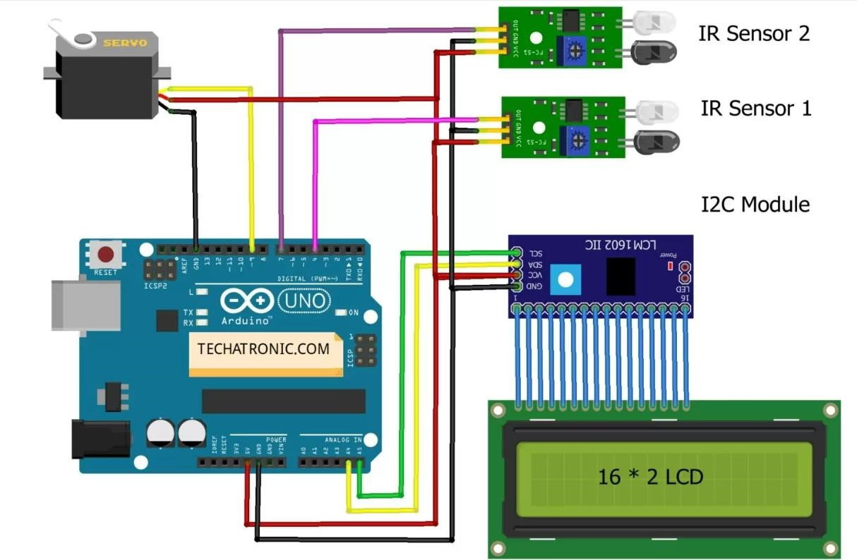

**PROGRAMMING CODE:**

#include <Wire.h>

#include <LiquidCrystal_I2C.h>

LiquidCrystal_I2C lcd(0x27,16,2);

#include <Servo.h> Servo myservo1; int IR1 = 4; // IR Sensor 1 int IR2 = 7; // IR Sensor 2

int Slot = 4; //Enter Total number of parking Slots int flag1 = 0; int flag2 = 0; void setup()

{ lcd.init(); lcd.backlight(); pinMode(IR1, INPUT); pinMode(IR2, INPUT); myservo1.attach(9); myservo1.write(100); lcd.setCursor (0,0); lcd.print(" ARDUINO "); lcd.setCursor (0,1); lcd.print(" PARKING SYSTEM "); delay (2000); lcd.clear();

} void loop(){

if(digitalRead (IR1) == LOW && flag1==0){ if(Slot>0){flag1=1;

if(flag2==0){myservo1.write(0); Slot = Slot-1;}

}else{ lcd.setCursor (0,0); lcd.print(" SORRY :( "); lcd.setCursor (0,1); lcd.print(" Parking Full "); delay (3000); lcd.clear();

}

}

if(digitalRead (IR2) == LOW && flag2==0){flag2=1; if(flag1==0){myservo1.write(0); Slot = Slot+1;}

}

if(flag1==1 && flag2==1){ delay (1000); myservo1.write(100); flag1=0, flag2=0;

} lcd.setCursor (0,0); lcd.print(" WELCOME! "); lcd.setCursor (0,1); lcd.print("Slot Left: "); lcd.print(Slot);

}

**RESULTS:** Made automatic car parking system using Arduino